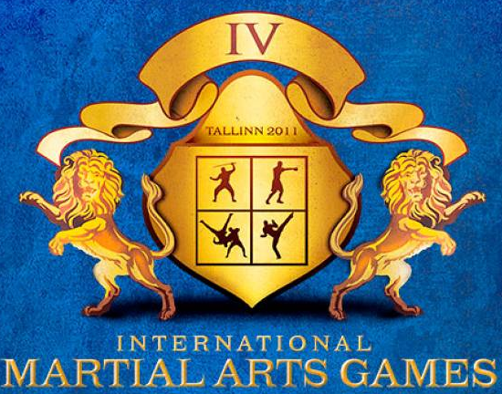


ORIENTAL MARTIAL ARTS
Amateur MMA sport

Tallinn, Estonia
23-27 February 2011

- PROMOTOR & ORGANISATORS:
- INTERNATIONAL MARTIAL ART GAMES COMMITTEE
- Estonian Martial Arts Union
- Estonian Taekwon-do Union
- International Oriental Martial Arts Federation

- FIGHTING STYLES:
MIX-FIGHT / SHOOT-FIGHT / SAFE-FIGHT

- DIVISIONS:

- Mix-fight:
Division | Age | Weight category , kg
Men | 1971-93 | 54 | 57 | 60 | 63,5 | 67 | 71 | 75 | 81 | 86 | 91 | +91

- Shoot-fight:
Division | Age | Weight category , kg
Men | 1971-93 | 54 | 57 | 60 | 63,5 | 67 | 71 | 75 | 81 | 86 | 91 | +91
Women | 1971-93 | 48 | 52 | 56 | 60 | 64 | 68 | 72 | +72
Junior A (male) | 1994-95 | 51 | 54 | 57 | 60 | 63,5 | 67 | 71 | 75 | 81 | 86 | +86
Junior A(female) | 1994-95 | 45 | 48 | 52 | 56 | 60 | 64 | +64

- Safe-fight
Division | Age | Weight category , kg
Men | 1971-93 | 54 | 57 | 60 | 63,5 | 67 | 71 | 75 | 81 | 86 | 91 | +91
Women | 1971-93 | 50 | 55 | 60 | 65 | 70 | 75 | +75
Junior A (male) | 1994-95 | 50 | 55 | 60 | 65 | 70 | 75 | 80 | 85 | +85
Junior A(female) | 1994-95 | 45 | 48 | 52 | 56 | 60 | 64 | +64
Junior B (male) | 1996-98 | 43 | 45 | 48 | 51 | 54 | 57 | 60 | +60
Junior B(female) | 1996-98 | 41 | 43 | 48 | 51 | 54 | 57 | +57

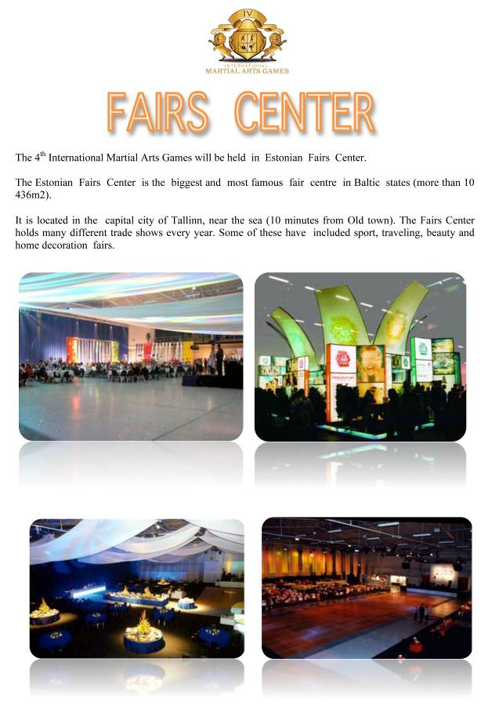
SPORT HALL

- JUDGES AND REFEREES
Those who are Interested in participating as judges and referees should be informed, that they are going to attend a seminar. All Delegations are obligated to bring at least one (1) Judge or referee otherwise they will face a penalty.

- TERMS FOR PARTICIPATION
- Allowed to start: Fighters of any styles and organizations, with a medical attest.
- Starting fees (Registration till January 10th): 45 €.
Sportsmen registered after January, 10th will pay 80 €.
- Each Team should bring along their National Anthem in a CD
- Each fighter is obligated to prove his nationality and Age, by providing the Travel Passport or any other official document
- All Teams that wish to participate shall send the Participation Statement which has been send with this Invitation by e-mail sportarts@mail.ru until the 10th of January. Please be sure you mention the correct age and exact weight of each fighter.

- IMGC REGISTRATION
ID Registration for person 35 euro
The ID package includes:
- International Martial Arts Games ID card
- Transportation from hotel to Arena and back
- Transport from Airport to hotel, on arrival and departure
- Free entrance to the sport hall

- ACCOMMODATION

 | Single  (per person/night) | Double  (per person/night) | Triple  (per person/person)
ACCOMMODATION PACKAGE “A” | 95 euro | 80 euro | 75 euro
ACCOMMODATION PACKAGE “B” | 75 euro | 60 euro | 55 euro
ACCOMMODATION PACKAGE “C” | 55 euro | 45 euro | 40 euro

Triple room is available with this price only if at least one person is less then 17 years old.

- CONTACT – VISA DOCUMENT
For more Information or Visa Documents please contact Organizing committee office.
Documents for the visa must be delivered to us 45 days:
Telephone: +74957891500
Email: sportarts@mail.ru

- PROGRAM OF THE EVENT

23.02.2011 Arrival and Registration IMGC
24.02.2011 09:00-11:00 Weight In,
4th IMG Congress Umpire and coaches meetings
25.02.2011 10:00-19:00 Competition Opening Ceremony
26.02.2011 10:00-19:00 Competition
27.02.2011 10:00-19:00 Competition IMG party
28.02.2011 Excursions & Departure

